**50. I am Alive: Prayer**

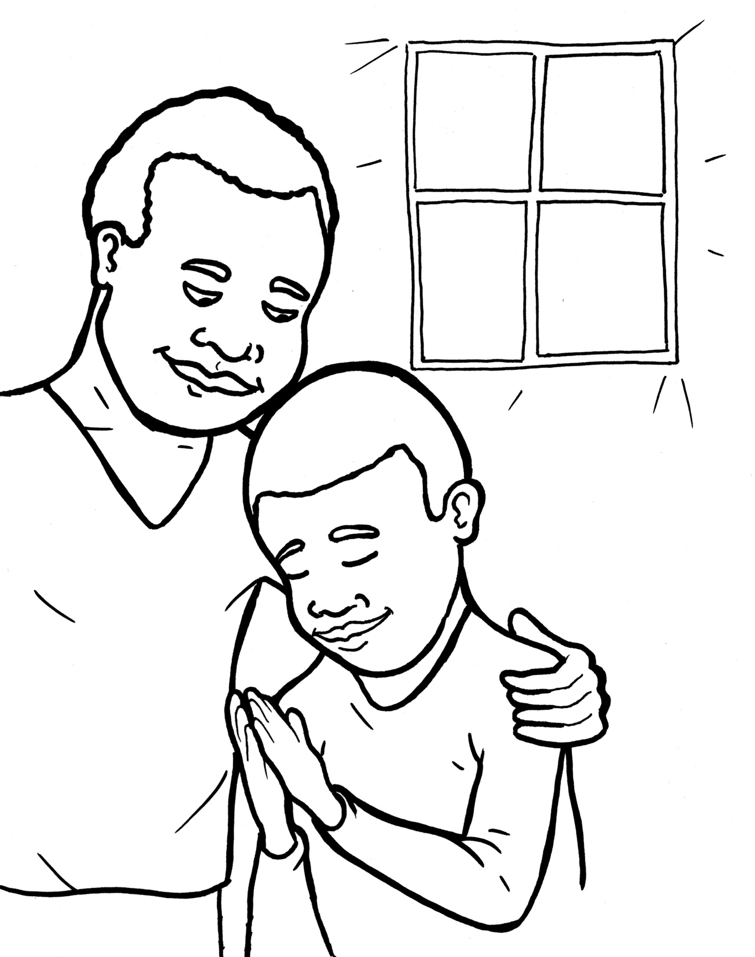

Pray in the Spirit always with all kinds of prayers

and requests.

Ephesians 6:18

Part 1 **I am Alive:** **Prayer** Words in Syllable Types

|  |  |  |  |
| --- | --- | --- | --- |
| **Closed**  short vowel  st**o**p | **Open**  long vowel  g**o** | **Silent e**  long vowel  c**a**v**e** | **Vowel Teams**  long vowels  **ea**t |
| **a**n- th**a**t  f**a**m- h**a**p-  p**a**t- -v**a**nt  **e**v- -p**e**ns  wh**e**n -t**e**n  y**e**s -m**e**n    **i**n- -**i**l- **i**m -sh**i**p  s**i**ns th**i**s  **o**f-G**o**d f**o**l- n**o**t  **u**s j**u**st | **a** men  a m**a** zing  h**e** m**e**  w**e** r**e** joice  **o** pens  **o** bey  b**y**  sor r**y**  hap p**y**  might **y**  ever **y**  famil **y**  honest **y** | s**a**m**e** m**a**k**e**  l**i**k**e**  l**i**f**e**  a l**i**v**e** | d**ay** pr**ay**  w**ai**t pr**ai**se  o b**ey**  n**ee**d  k**ee**p  sw**ee**t  **ea**rs d**ea**r  h**ea**r **ea**ch  r**igh**t  m**igh**t y  gr**ow**  fol l**ow**  f**oo**d |
| **Vowel Teams**  other sounds **oi**l | **R-controlled**  **or**ange | **Consonant**  **l-e** pur**ple** | **Other** |
| h**ow**  **ou**r **ou**ch  s**ou**nd a b**ou**t  v**oi**ce  re j**oi**ce  g**oo**d  br**ea**th | st**ar**t  f**or or** der  s**er** vant  or d**er**  pat t**er**n  an sw**er**s  ev **er** y  l**ear**n | **Other sounds**  -ind,-old,-etc.  c**old**  t**old**  al m**ost**  **Other**  -**nk**, -**ng**  b**ank,** th**ing**  s**ing** k**ing**  l**ong**s s**ong**  th**ank** | schwa  MC900250834[1]MC900250834[1]b**a** nan **a**  **a** live  **a** bout  **a** maze |

.

Part 2 **I am Alive:** **Prayer**  New Words, Rule Breakers

**Soft c ce**nt, **ci**ty, fan**cy**

rejoi**ce** voi**ce**

**Silent letters**

ans**w**ers lis**t**en ta**l**k **h**onesty

**Contractions** I**’**m = I **a**m

let**’**s = let **u**s

**New Words**

Christian

honesty

praise

**Rule Breakers**

is

to

his

the

you

your

from

sure

give

been

what

wants

would

friend

into

sorry

listen

water

Father

answers

Christian

Part 3 **I am Alive:** **Prayer** Dividing Words into Syllables

|  |  |  |  |  |
| --- | --- | --- | --- | --- |
| **Broken into**  **syllables** | **Full Words** |  | **Broken into**  **syllables** | **Full Words** |
| 1. ra**b b**it words | MC900325566[1] |  | 2. ti **g**er words | **MC900183858[1]** |
| Chris tian | Christian |  | o pens | opens |
| or der | order |  | o bey | obey |
| of ten | often |  | re joice | rejoice |
| lis ten | listen |  | a men | amen |
| ser vant | servant |  |  |  |

.

|  |  |  |  |  |
| --- | --- | --- | --- | --- |
| **Broken into**  **syllables** | **Full Words** |  | **Broken into**  **syllables** | **Full Words** |
| 3. ca**m** el words | MC900356151[1] |  | 4. ha**m** **st**er  words | MC900111940[1] |
| hon est y | honesty |  | an swer | answer |
| fam il y | family |  |  |  |
| ev er y | every |  | 5. other syllable divisions |  |
|  |  |  | a bout | about |
|  |  |  | a live | alive |
|  |  |  | a mazing | amazing |

.

|  |  |  |  |  |
| --- | --- | --- | --- | --- |
| **Broken into**  **syllables** | **Full Words** |  | **Broken into**  **syllables** | **Full Words** |
| 6. fox**es**  suffix**es** |  |  | 7.ant eater  compound words |  |
| might y | mighty |  | in to | into |
| honest y | honesty |  |  |  |
| pray ers | prayers |  |  |  |
| tell ing | telling |  |  |  |
| pray ing | praying |  |  |  |
| wait ing | waiting |  |  |  |
| a ma zing | amazing |  |  |  |
| friend ship | friendship |  |  |  |

.

Part 4 **I am Alive:** **Prayer** Easy Read English

For a Christian, praying is like air. It is our breath. It is our life with God. He is our best friend and king!

In order to keep a friendship alive, you need to talk to your friend, right? It is the same with God. He longs to hear from you. You are his sweet child. He is waiting.

Let’s make sure our prayers are not just about us. Prayers can often sound like this: “Dear God, Give me this. Give me that. Amen.” Ouch! God is not our servant. We are his servants. Learn to follow this prayer pattern. It will help you grow into a mighty, praying Christian.

**I P-R-A-Y**

**“I** am sorry.” Start by telling God the sins you’ve been doing. Our honesty opens his ears.

**P**raise him! Tell him how amazing he is. Sing him a praise song. That makes him happy.

**R**ejoice! Thank him for prayers he answers. Give thanks for your food, water, family, and good life.

**A**sk him for help and for what you would like. He is your Father. He wants to bless and help you.

**Y**es. Listen for his voice. “Yes, God, I want to obey.”

Each and every day, God hears you when you pray.

**Questions**

1. What is prayer?
2. Why is prayer important for you and God?
3. What praise songs do you know?
4. Why is the I P-R-A-Y pattern good to learn?

**Prayer**

Dear Lord Jesus,

**I** am sorry for my sins, like not obeying.

**P**raise to you for being so kind and forgiving.

**R**ejoice! Thank you for teaching me.

**A**sk. I am asking you to help me grow in prayer.

**Y**es. I will obey you. I will pray to you.

Amen

Write in the hand the five ways

to pray. It will spell I PRAY.

**I** am sorry

**P** raise God

**R** ejoice! Give thanks

**A** sk what you like

**Y** es, I will obey

**I am Alive:** **Prayer** Phrased for Fluency

For a Christian**,** praying is like air**.** It is

our breath**.** It is our life with God**.**

He is our best friend and king**!**

In order to keep a friendship alive**,**

you need to talk to your friend**,** right**?** It is the same with God**.**  He longs to hear from you**.** You are his sweet child**.**  He is waiting**.**

Let**’**s make sure our prayers are not just about us**.** Prayers can often sound like this**:** **“**Dear God**,** Give me this**.** Give me that**.** Amen**.”** Ouch**!**  God is not our servant**.**  We are his servants**.** Learn to follow this prayer pattern**.** It will help you grow into a mighty**,** praying Christian**.**

**I P-R-A-Y**

**“I** am sorry**.”** Start by telling God the sins you’ve been doing**.**  Our honesty opens his ears**.**

**P**raise him**!** Tell him how amazing he is**.** Sing him a praise song**.**

That makes him happy**.**

**R**ejoice**!** Thank him for prayers

he answers**.** Give thanks for your food**,** water**,** family**,**  and good life**.**

**A**sk him for help and for what you

would like**.**  He is your Father**.**

He wants to bless and help you**.**

**Y**es. Listen for his voice**.**

**“**Yes**,** God**,** I want to obey**.”**

Each and every day**,**

God hears you when you pray**.**

Part 5 **I am Alive:** **Prayer** Vocabulary

|  |  |
| --- | --- |
| 1. cherish (CH**ER** - **i**sh):  hold as dearly loved | 2. Yahweh (YAH - weh):the Hebrew name of God |
| 3. cease (**cea**s**e**): stop | 4. boldness(BOLD - ness): being brave |
| 5. grace (grace): special kindness | 6. commandments(com – MAND – ments):God’s laws for humans |

**I am Alive: Prayer - I P-R-A-Y**

Ephesians 6:18 and others World English Bible (WEB)

When Jesus finished praying in a certain place, one of his disciples said to him, “Lord, teach us to pray...”

Luke 11:1a

**I** am sorry

If I cherished sin in my heart, the Lord wouldn’t have listened.

Psalm 66:18

**P**raise him!

Yahweh, how many are your works! In wisdom, you have made them all. The earth is full of your riches.

Psalm 104: 24

**R**ejoice!

Always rejoice. Pray without ceasing. In everything give thanks, for this is the will of God in Christ Jesus toward you.

1 Thessalonians 5:16-18

**A**sk him for help and for what you would like.

Let’s therefore draw near with boldness to the throne of grace, that we may receive mercy and may find grace for help in time of need.

Hebrews 4:16

**Y**es. “Yes, God, I want to obey.”

If you love me, keep my commandments.

John 14:15

Pray at all times in the Spirit. Ephesians 6:18b